**Normal Distribution: What It Is, Properties, Uses, and Formula**

**1. Definition and Key Takeaways:**
- Normal distribution, also known as Gaussian distribution, is symmetric about the mean.
- It appears as a "bell curve."
- Mean is zero, standard deviation is 1, with zero skew and kurtosis of 3.
- Not all symmetrical distributions are normal.

**2. Understanding Normal Distribution:**
- Common in technical stock market analysis and statistical analyses.
- Parameters: mean and standard deviation.
- Central Limit Theorem (CLT) states averages from independent, identically distributed random variables are approximately normal.

**3. Properties of the Normal Distribution:**
- Mean, median, and mode are equal and represent the peak.
- Symmetrical around the mean, width defined by standard deviation.
- Described by mean and standard deviation.

**4. The Empirical Rule:**
- Describes the percentage of observations within standard deviations from the mean.
- 68.2% within ±1 standard deviation, 95.4% within ±2, and 99.7% within ±3.
- "Empirical rule" for normal distribution.
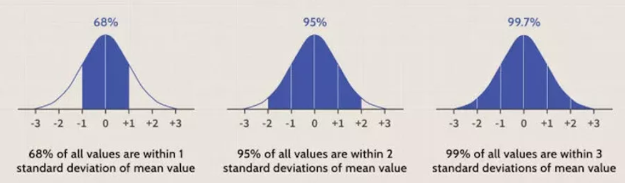

**5. Skewness and Kurtosis:**
- Skewness measures symmetry; normal distribution has skewness of zero.
- Kurtosis measures tail thickness; normal distribution has kurtosis of 3.0.
- Leptokurtic (>3.0) has "fat tails," platykurtic (<3.0) has less extreme tails.

**6. Formula for Normal Distribution:**
- Formula involves mean (μ) and standard deviation (σ).
- x = value, f(x) = probability function.

**7. Usage in Finance:**
- Assumption applied to asset prices and price action.
- Traders use deviations to suggest potential trades.
- Asset price distributions often have fat tails.

**8. Example of a Normal Distribution:**
- Heights of human beings as a naturally occurring example.
- 99.7% within ±3 standard deviations of the mean.

**9. Origin and Terminology:**
- Gaussian distribution; termed "normal" due to observations "deviating normally" from the mean.
- Popularized as the "normal curve" by Francis Galton in 1889.

**10. Limitations in Finance:**
- Applications in finance limited due to financial phenomena not neatly fitting normal distribution.
- Prices tend to follow a log-normal distribution with right-skew and fatter tails.
- Relying on a bell curve for predictions in finance can lead to unreliable results.

**T-Distribution in Probability: Understanding and Usage**

**1. Definition and Characteristics:**
- The t-distribution, or Student’s t-distribution, is a probability distribution similar to the normal distribution but with heavier tails.
- Used for estimating population parameters in small sample sizes or cases of unknown variances.
- Basis for computing t-tests in statistics.

**2. Key Takeaways:**
- Continuous probability distribution of the z-score, where the estimated standard deviation is used.
- Bell-shaped and symmetric like the normal distribution but with fatter tails.
- T-distributions have a greater chance for extreme values.

**3. Degrees of Freedom and Tail Heaviness:**
- Tail heaviness determined by degrees of freedom.
- Smaller values result in heavier tails, resembling a standard normal distribution with mean 0 and standard deviation 1.
- Higher degrees of freedom make the distribution approach a standard normal distribution.

**4. Calculating T-Scores:**
- When using estimated standard deviation, a t-score is calculated as T = (m – M)/{d/sqrt(n)}.
- Involves (n - 1) degrees of freedom, unlike the normal distribution with mean 0 and standard deviation 1.

**5. Example of Usage:**
- Confidence interval for the mean is calculated as m +- t*d/sqrt(n).
- Critical value 't' is obtained from the t-distribution.
- Example: 95% confidence interval for the DJIA mean return, adjusting for standard errors.

**6. T-Distribution vs. Normal Distribution:**
- Both used when assuming a normally distributed population.
- T-distribution has fatter tails and higher kurtosis.
- Probability of extreme values is larger with a t-distribution.

**7. Limitations and When to Use:**
- T-distribution may lack exactness relative to the normal distribution.
- Should be used when the population standard deviation is unknown or for small sample sizes.
- Normal distribution is preferred for larger sample sizes with a known standard deviation.

**9. The Bottom Line:**
- The t-distribution is crucial in estimating significance for small samples or unknown variations.
- Like the normal distribution, it is bell-shaped and symmetric, but its heavier tails allow for a greater chance of extreme values.
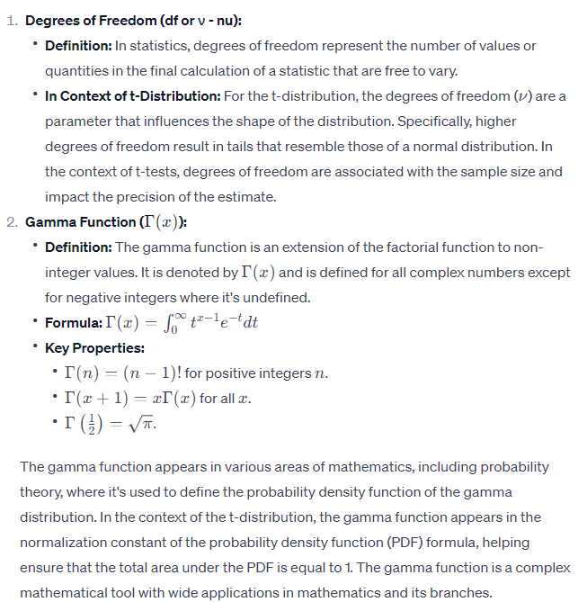

Central Limit Theorem Statement
The central limit theorem states that whenever a random sample of size n is taken from any distribution with mean and variance, then the sample mean will be approximately a normal distribution with mean and variance. The larger the value of the sample size, the better the approximation of the normal.

Assumptions of the Central Limit Theorem
- The sample should be drawn randomly following the condition of randomisation.
- The samples drawn should be independent of each other. They should not influence the other samples.
- When the sampling is done without replacement, the sample size shouldn’t exceed 10% of the total population.
- The sample size should be sufficiently large.

